# Chart 1

### 显示效果：

* 1. 横坐表每一个点的深度，纵坐标对应元素的值

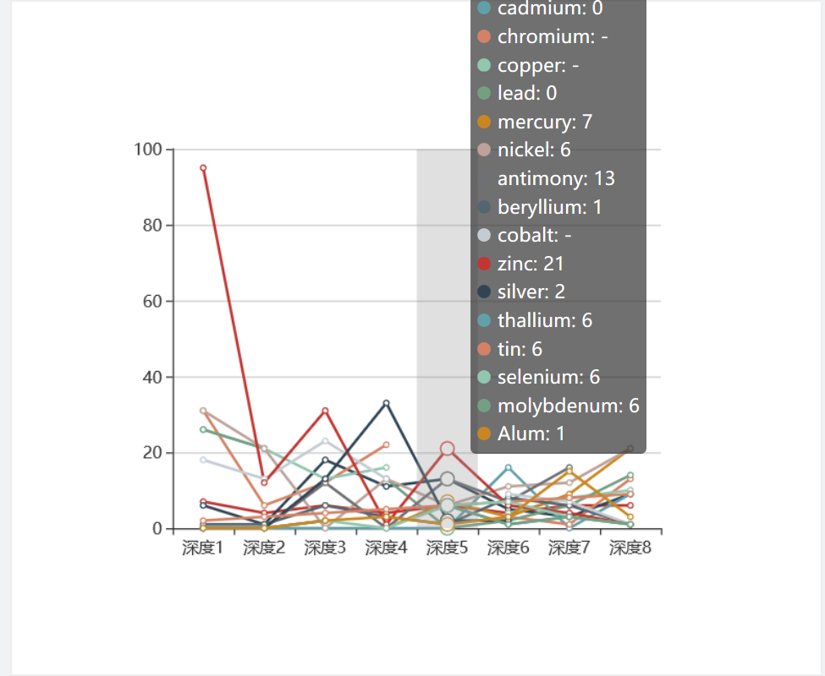

### 数据

1. 数据一：横坐标——深度数组的长度根据数据库的表格中取出，以数组显示
   * + 如arr = ["深度1", "深度2", "深度3", "深度4", "深度5", "深度6", "深度7", "深度8"]
2. 元素种类，根据不同项目点取出所有元素，以数组返回
   * + Array = ["PH", "arsenic", "cadmium", "chromium", "copper", "lead", "mercury", "nickel", "antimony", "beryllium", "cobalt", "zinc", "silver", "thallium", "tin", "selenium", "molybdenum", "Alum"]
3. 对应元素种类的对象数组
   * + [object Array]: [Object, Object, Object, Object, Object, Object, Object, Object, Object, Object, Object, Object, Object, Object, Object, Object, Object, Object]
       - 其中每一个object的形式如下，拿PH举例
         * {name: "PH", type: “line”, value: xxx }

其中name根据Array中的数据获得

Type为定值

Value为数据库中对应元素的数据

# Chart 2

### 显示效果

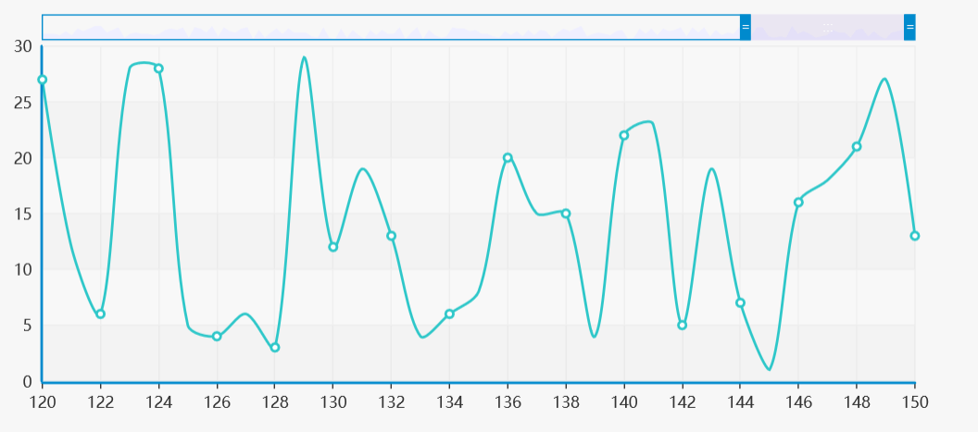

### 数据

1. 要求1：**日期数组**——横坐标显示时间日期，时间日期范围要求是150天（若不够则展示所有天），从而可以通过时间轴进行动态的展示
   1. 要求是筛选出来的日期按顺序排列的数组
2. 要求2：相应日期的**元素对应值**——以数组返回：
   1. 按照日期顺序排列的特定元素的值
3. 要求3：要求**所有元素**可选

# Chart 3

### 显示效果

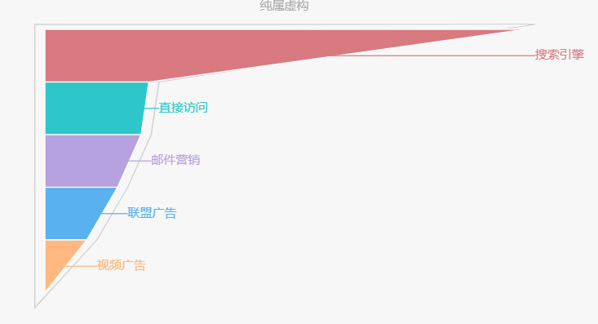

### 数据

1. 要求1：**元素类型**的数组
   1. 返回具体项目体的元素数组Array = ["PH", "arsenic", "cadmium", "chromium", "copper", "lead", "mercury", "nickel", "antimony", "beryllium", "cobalt", "zinc", "silver", "thallium", "tin", "selenium", "molybdenum", "Alum"]
2. 要求2：返回对应元素

series : [

{

name:'元素比例值',

type:'pie',

radius : '55%',

center: ['50%', '60%'],

data:[

{value:335, name:'PH'},

{value:310, name:'arsenic'},

{value:234, name:'cadmium'},

{value:135, name:'chromium'},

{value:1548, name:'…'}

]

}

]